**Java Final Report**

Zijun Xia

CMPSC111-4

Course project

Janyl Jumadinova

December 6

Java is an interesting and useful language, and we can use it to create many computer programs. When others mention java, at the first time, I just think about java game in my mind. As I know, people have created many java games, like super Mario and fruit ninja. However, for this semester, we have learnt some basic java knowledges that most only output text. So, I thought I can use those java knowledges to create a text java game.

When I was a little boy, I had played some fight games, like Cadillacs and Dinosaurs. So, I wanted to create a game that player is a hero and computer is the dragon. Firstly, they both have 20 point hit points and zero magic point, and each time player and dragon both can choose save energy which means add one point magic point, defense, attack which can decrease opponent one hit point, and do magic attack that cannot be defensed and decrease opponent two hit points, but it will consume three magic points. Final, when hero or dragon’s hit point less or equal to zero, will lose the game. In order to complete this project, I use one class to write the main class, which calls other method in the class. Another class is that print the introduction of this game. Then, for the last class, I write all the methods that about the explanation of hero and dragon’s hit points and magic points, how to decrease the hit points and increase the magic points, and how can hero or dragon lose. I use a while loop and many for loops in my project, and I also use Boolean to judge whether break the 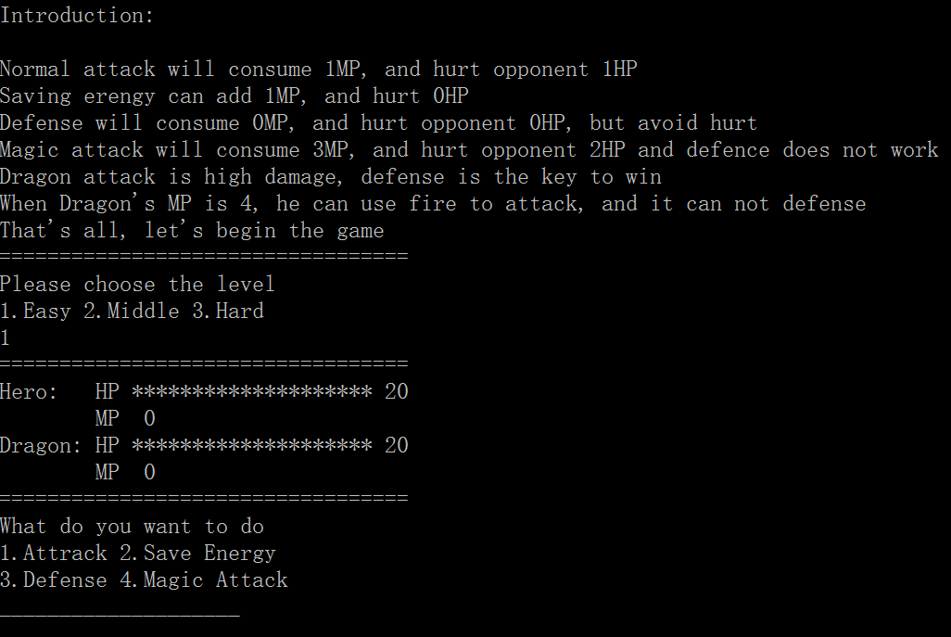program that end the game.

Here is my output for the introduction, level choosing and command choosing. Then, the player can choose one of four commands to offense and defense.

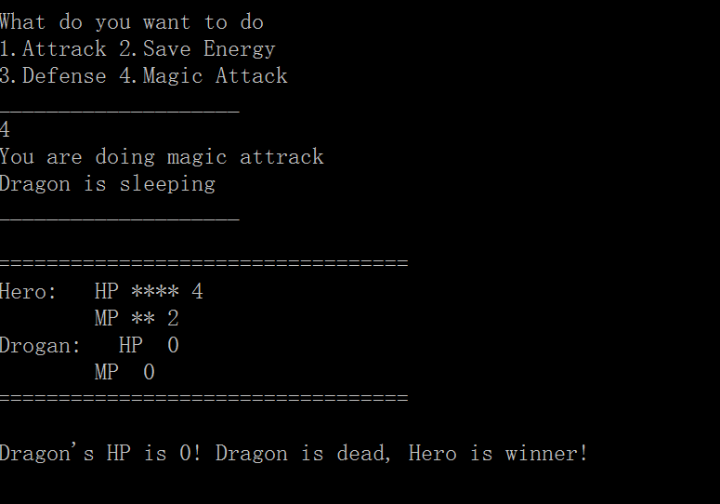

Here is the final result that hero kill dragon and become the winner.

All in all, I go through knowledges that I have learnt this semester, and let me be more familiar with those knowledges. For the biggest challenge, it is that hit points and magic points’ output. When I faced this problem, I really felt agitated and did not how to do. However, when I was calm down, I came up with an idea to solve it. So, the biggest reward that I earn is that when I encounter a problem of programming, I should be calm down to think about the solvation rather than be agitated.